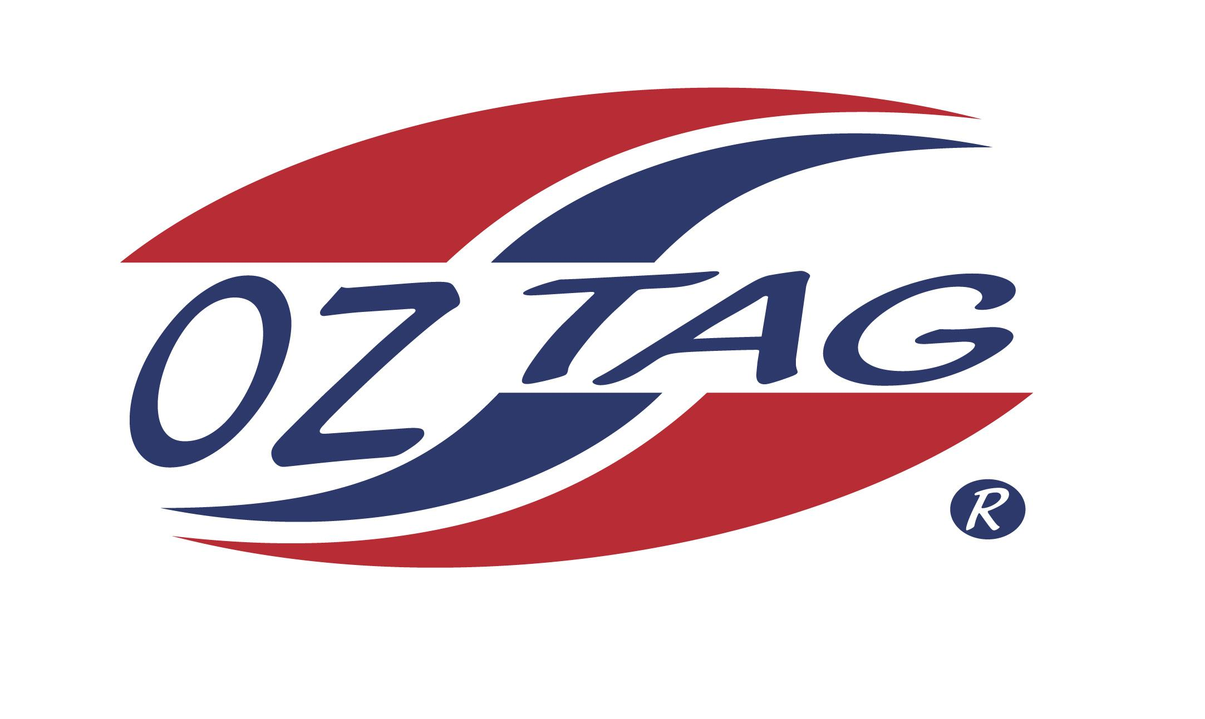
Girls under 12 Sutherland Representative
Team 2020

Congratulations to the following players selected in the 2020 State
Team for Sutherland.

Name
1. Antonnea Arfanis
2. Bella Myers
3. Bridget Rommel
4. Abbie Jackson
5. Bronte Snoxall
6. Chloe Ozolins
7. Charlotte Woolnough
8. Zoe Noble
9. Ruby Hedley
10. Martha Gregory
11. Millie Cowie
12. Zara Loveday
13. Nova Batman
14. Sarah Hickey
15. Paige Hagan
16. Isabella Harrison
SHADOWS:
17. Ellie Glazier
18. Emily Gavin
19.
20.

Division 1

Coach: Jason Snoxall Phone: 0423584375
Email: jason@sydneysurvivors.com.au

Manager: Phone:
Email:

