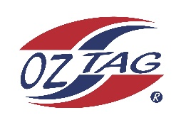
Menai Storm 2020
Under 11’S Representatives
Junior State Cup Bass Hill

Congratulations to the following players selected in the under 11’s
Menai Storm team.

Name
1. Moey Spiros
2. Zarr Murupaenga
3. Jye Lopez
4. Ryder Creeke
5. James Tsavalias
6. Caleb Hayes
7. Lachlan Hayes
8. Todd Wardman
9. Takaki King
10. Alex Carroli
11. Jye Conlan-Bullock
12. Caleb Bunker
13. Max Maurer
14. Jake Patterson
SHADOWS:
15.Ethan Dogger
16. William Saunders
17. Robert Crilley

Division: UNDER 11

Coach: SCOTT WARDMAN
Phone:0497301141
Email: wardo87@hotmail.com

Manager: Nicole Conlan
Phone: 0422564590
Email: nicoleconlan@optusnet.com.au

