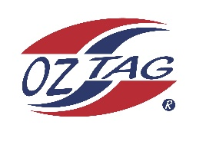
2020 State Cup
Under 16 Girls Representative Squad

Congratulations to the following players selected in the 2020 State Cup Squad. A Final team of 16 will be announced early December 2019.

Name
1. Niamh Behringer
2 Tayla Bell
3 Amber Cottrell-Dormer
4. Abbey-Rose Cryer
5. Keira Danes
6. Amelia Feeney
7. Paige Fleming
6. Eve Gardener
7. Georgia Greig
10. Jade Hook
11. Jasinta Lewins
12. Charly Lloyd
13. Jasmin Saunders
14. Maddie Taylor
15. Zoe Topham
16. Angie Tucker
17. Capri Tuffy
18. Ava Wilson

Division: Under 16 Girls

Coach: Gary Cottrell-Dormer Adam Cryer
Phone: 0413 889 505 0408 662 227
Email: Sales@pubworksconstruction.com.au amcryer@bigpond.com

Manager: Terri Lloyd
Phone: 0412 266 612
Email: tez4@optusnet.com.au

