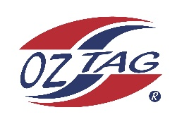
Cronulla Sharks 2020
Under 15 girls Representatives
Junior State Cup Coffs Harbour

Congratulations to the following players selected in the under girls 15
Cronulla Sharks team.

Name
1. Christie Natoli
2. Bronte Laffan
3. Rosie Degnan
4. Zara Baccon
5. Sienna Arthur
6. Caitlin Gibbs
7. Lailah Sheridan
8. Ella Oates
9. Demi Bresnahan
10. Kira Hensley
11. Jade Tattam
12. Sophie Kay
13. Jasmine Rose
14. Tess Robinson
15. Ruby Cafe
16. Tess Corbett
SHADOWS:
17.
18.
19.
20.

Coach: David Rose Division: Girls 15
Phone: 0408226842 Email: david@theroses.com.au

