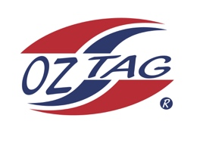
Boys under 13 Cronulla Representative
Team 2020

Congratulations to the following players selected in the 2020 State
Team for Cronulla.

Name
1. Jacob Benton
2. Ethan Kiehne
3. Joel Cornock
4. Dylan Keys
5. Zayne Kennedy
6. Isaac Lopes
7. Jarvis Wever
8. Tate Nicholls
9. Harrison Cavanagh
10.Zac McPherson
11.Tommy Franks
12.Jett Murphy
13.Cody Beckett
14.
15.
16.
SHADOWS:

Division

Coach: Lee Murphy/Brad Cavanagh Phone:
Email:

Manager: Phone:
Email:

