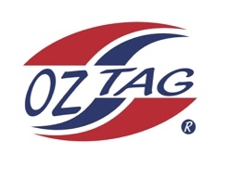
Boys under B10 Cronulla Representative
Team 2020

Congratulations to the following players selected in the 2020 State
Team for Cronulla.

Name
1. Cruz Wever
2. Cooper Laverance
3. Randy Ennis
4. Jack McKevett
5. Bear Laffan
6. Bailey Silver
7. Alex Slattery
8. Zane Smith
9. Tyler Moon
10. Ethan Mullins
11. Roy Eisenhuth
12. Jax Lees
13. Kash Lemke
14. Lenny Bucher
15. Cooper Brenton
16. Liam Lakomy
SHADOWS:
17. Jake Mott
18. Harry Newham
19.
20.

Division 10 Boys

Coach:Paul Laffan
Phone:0419288851
Manager:Leanne Laffan. Phone: 0409922773

Please text Leanne to accept your position in the team

