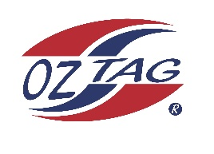
Boys under 17s Heathcote/Engadine
Representative
Team 2020

Congratulations to the following players selected in the 2020 State
Team for Heathcote/Engadine.

Name
1. Tom Strover
2. Brodie Ballard
3. Jake Bonser
4. Conor Robson
5. Luke Bishop
6. Sam Woerndl
7. Cooper Noakes
8. Zane Ryan
9. Jay Versluis
10. Brynn Magson
11. Kobie Wilson
12. Braydan Andrews
13. Rory Mcnally
14. Josh Geddes
15. Jake Zoppi
16. Ryan Bardan
SHADOWS:
17.
18.
19.
20.

Division

Coach: Phone:
Email:

Manager: Phone:
Email:

